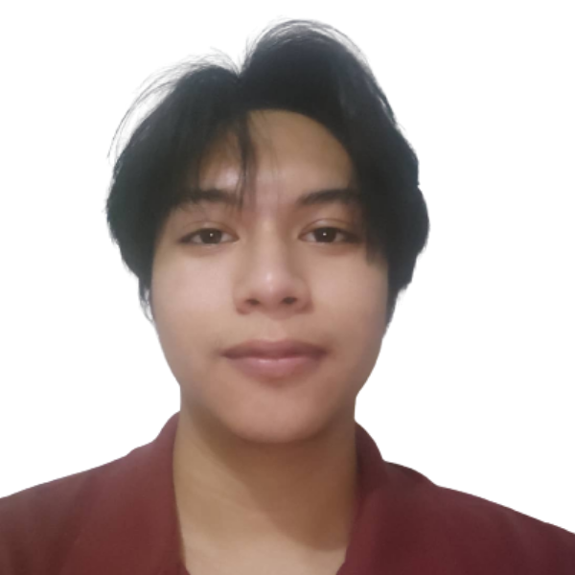

**Bren Punzalan**

punzalanbren@gmail.com  (63) 968-715-2768  Laguna, Calamba

**EDUCATION**

**STI COLLEGES**

*Laguna ,Calamba*

*GRADE-12 ITMAWD(IT in Mobile App and Web Development)*

* Lead Programmer in Research for STI’s Lost & Found
* Visual/Video Editor in AI(Arts) Club

**SKILLS & INTERESTS**

* **Skills:** 
  + Expertise of **JavaScript** and **React** and **Vue** Fundamental and Advance Topics,
  + Ability to code with modern tools such as **ES6**, **Babel**, and **webpack**, **NPM, Vite** and more.
  + Worked with **python** and python libraries such as (pandas, selenium).
  + Understanding of asynchronous request handling **Rest** (**APIs**), partial page updates, **Mongoose Database** and **AJAX**.
  + Experience with popular React.js workflows **Redux Toolkit** and more.
  + Ability to **integrate with back-end services** and APIs on **MongoDB**, **Express** and **Nodejs**.
  + Understanding of code versioning tools such as **Git**.
  + Knowledge in **Firebase** and various platforms pertaining for website deployment.
  + Understanding of **Docker**, **Kubernetes** and **Cloud** based services.
  + Knowledge of **Tailwind CSS**, **Material UI**, **Ant Design for Component Styling**.
  + Knowledge of **UI/UX Fundamentals** and **Figma**.
* Projects
  + <https://topcrypto-b8b58.web.app/>
    - A **cryptocurrency** web based application for currently top 100 cryptocurrency on any time with a chart and a screener for every cryptocurrency.
    - Uses **Coin gecko** API for data, **Material UI** for **UI/UX Design** and **React** for Development.
* **Interests:** 
  + Building websites for clients.
  + Learning new technologies in various field and expanding my knowledge.
  + Love solving interesting and challenging problems.
* **Additional**:
  + Communication Skills
  + Problem-Solving Skills
  + Time Management
  + Adaptability
  + Attention to Detail